Table of Contents

1. ls 4

2. dir 4

3. ls -a 4

4. ls -l 5

5. ls -lh 5

6. ls -F 5

7. ls -r 6

8. ls -R 6

9. ls -ltr 7

10. ls -i 7

11. ls --version 7

12. ls --help 8

13. ls -n 8

14. clear 8

15. mkdir 9

16. cd 9

17. touch 9

18. text editing 10

19. [bc]at 11

20. > 11

21. touch file1 file2 ... 12

22. cp 12

23. cd .. 12

24. pwd 13

25. cp <file_src> <file_dest> 13

26. mv 14

27. rm 14

28. rmdir 15

29. rm -rf 15

1. lscpu 16

2. [sudo] lshw 17

3. hwinfo [--short] 18

4. lspci 20

5. lsscsi 20

6. lsusb 21

7. inxi [-f][-F][-x] 21

8. lsblk 23

9. df 23

10. pydf 24

11. fdisk [-l] 24

12. free 25

13. dmidecode [-t <type>] 25

14. cat /proc/meminfo 28

15. cat /proc/version 28

16. hdparm [-i </dev/sata_device>] 29

17. uname [-n] [-r] 29

18. factor 30

19. bc 30

20. id 30

21. shutdown 31

22. ping 32

23. netstat [-r] 32

24. tcpdump 34

25. host google.com 34

26. tracepath achsnepal.edu.np 35

27. ifconfig 35

28. route 36

29. nslookup 36

30. whois 37

[31. pacman [-S[yy][u]] [package_name] 38](#__RefHeading___Toc429_3373028238_Copy_1t)

32. sl 39

33. sudo -s 39

34. exit 39

LAB 1 : BASIC LINUX COMMANDS

# ls

Interpretation: List information about the FILEs (the current directory by default)

Output:

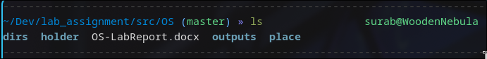

# dir

Interpretation: List information about the FILEs (the current directory by default)

Output:

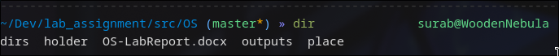

# ls -a

Interpretation: Lists contents and do not ignore entries starting with .

Output:

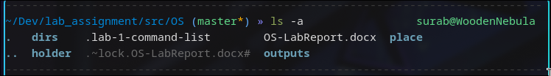

# ls -l

Interpretation: use a long listing format

Output:

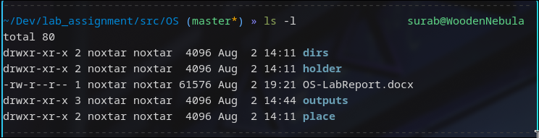

# ls -lh

Interpretation:

Lists contents along with human readable size formats

Output:

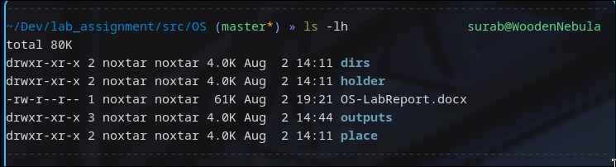

# ls -F

Interpretation: append indicator (one of */=>@|) to entries WHEN

Output:



# ls -r

Interpretation: reverse order while sorting

Output:

# ls -R

Interpretation: recursively list the directories

Output:

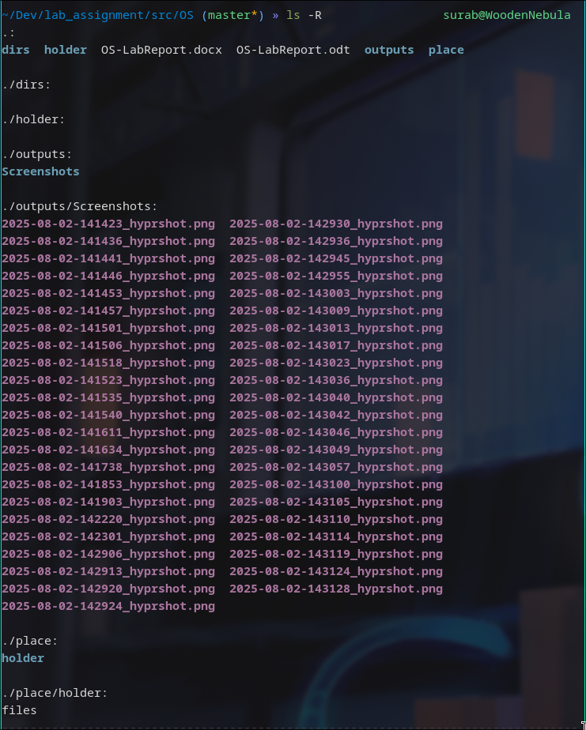

# ls -ltr

Interpretation: Lists contents in long listing sorted by time in reverse(oldest first) order

Output:

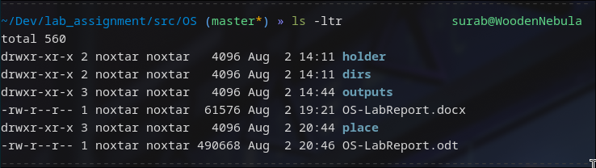

# ls -i

Interpretation: print the index number of each file

Output:

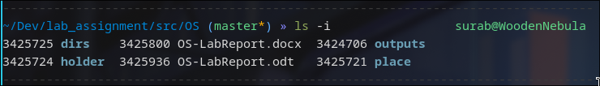

# ls --version

Interpretation: output version information and exit

Output:

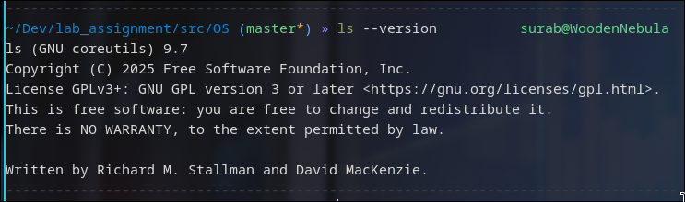

# ls --help

Interpretation: displays man/help page for the command ls

Output:

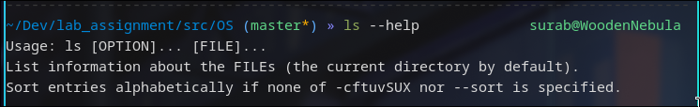

# ls -n

Interpretation: like -l, but list numeric user and group IDs

Output:

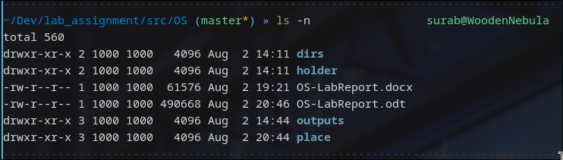

# clear

Interpretation: clears the terminal screen to default prompt

Output:



# mkdir

Interpretation: creates a directory with the provided name in current or supplied directory

Output:

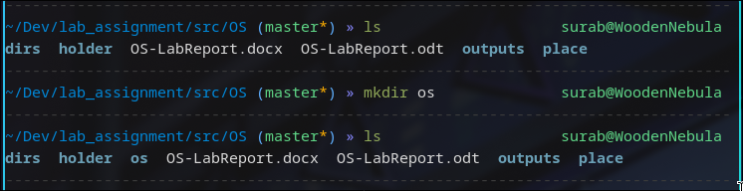

# cd

Interpretation: changes current directory to the supplied directory

Output:

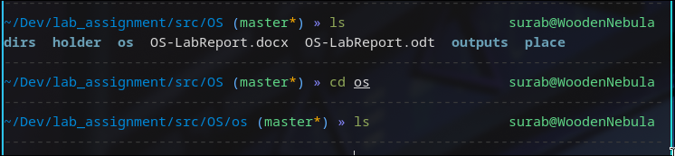

# touch

Interpretation: Updates the access and modification times of each FILE to the current. As a side effect, it creates the FILE if it doesn’t exist yet

Output:

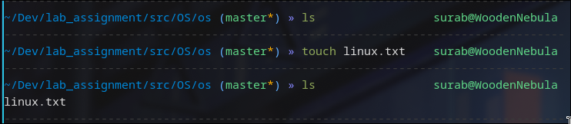

# text editing

Command: nano/vi/vim/nvim text-file

Interpretation: opens the text-file with the specific terminal based text editor

Output:



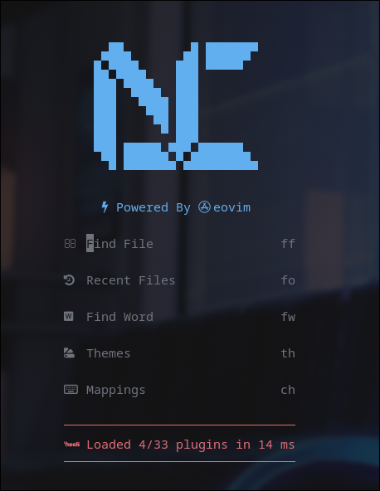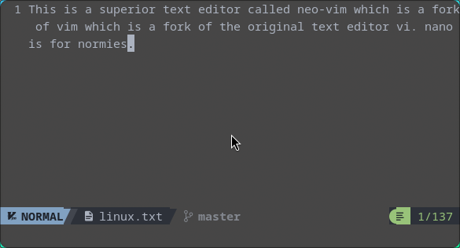

# [bc]at

Command: bat/cat

Interpretation: concatenate files and print on the standard output

Output:

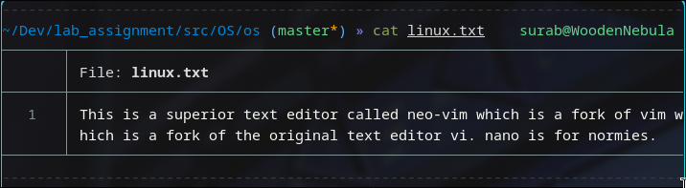

# >

Command: command > file

Interpretation: redirects the input from the command or stdin to the supplied file

Output:

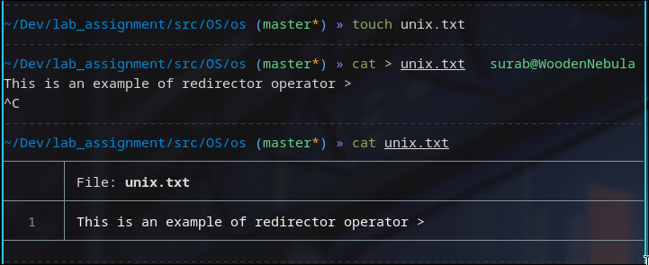

# touch file1 file2 ...

Interpretation: touches multiple supplied files

Output:

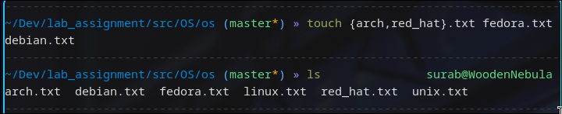

# cp

Command: cp <source> <dest>

Interpretation: copies content from source to destination

Output:

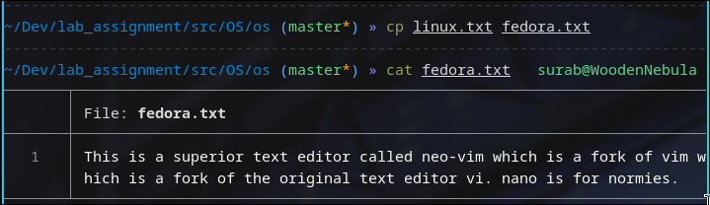

# cd ..

Interpretation: goes up a directory in current dir-tree

Output:

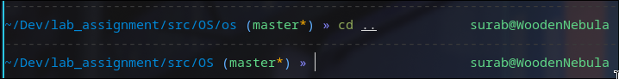

# pwd

Interpretation: prints current working directory

Output:

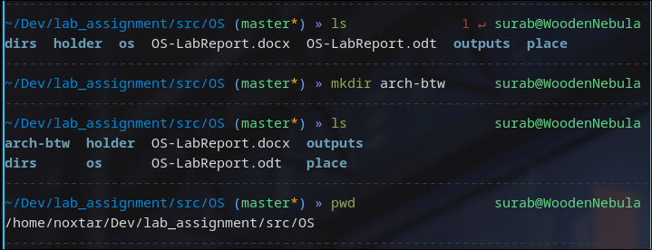

# cp <file_src> <file_dest>

Interpretation: Copies file from provided source to destination

Output:

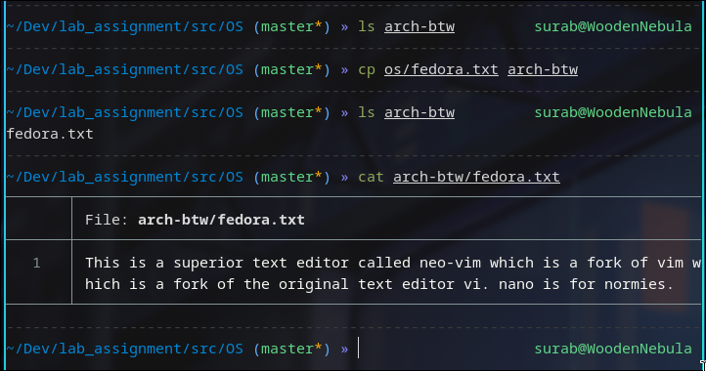

# mv

Interpretation: moves file from source to destination

Output:

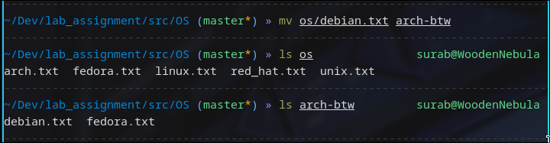

# rm

Command: rm <file1> <file2> ...

Interpretation: removes file at provided paths, wildcards can be used to pattern match as well for removing multiple files

Output:

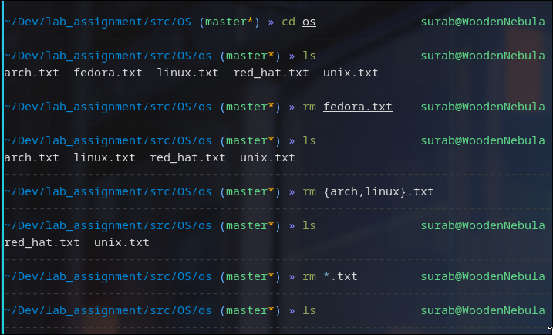

# rmdir

Command: rmdir <dir>

Interpretation: removes empty directory at supplied directory

Output:

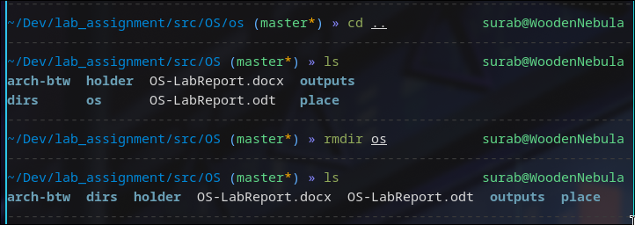

# rm -rf

Interpretation: remove supplied directory recursively and forcefully

Output:

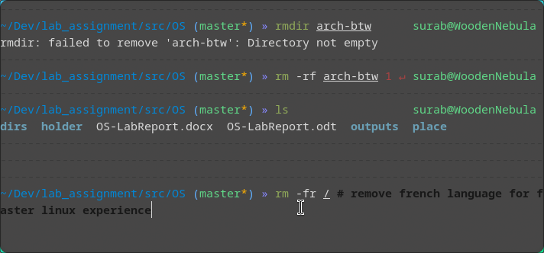

LAB 2 : INTERMEDIATE LINUX COMMANDS

# lscpu

Interpretation: lscpu gathers CPU architecture information from sysfs, /proc/cpuinfo and any applicable architecture-specific libraries. The information includes, the no. of CPUs, threads, cores, sockets, and NUMA nodes. There is also information about the CPU caches and cache sharing, family, model, bogoMIPS, byte order, and stepping.

Output:

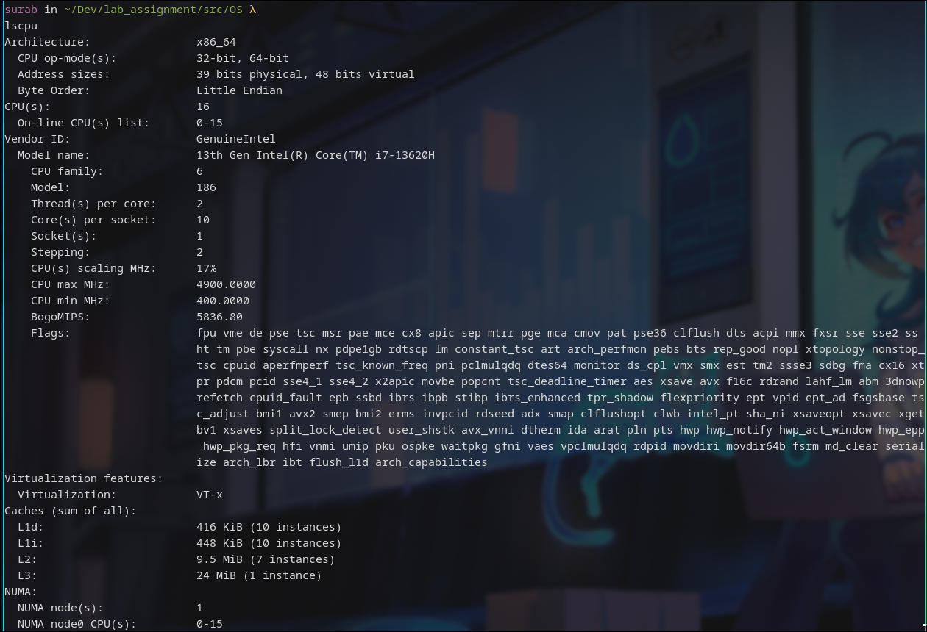

# [sudo] lshw

Interpretation: lshw is a small tool to extract detailed information on the hardware configuration of the machine. It can report exact memory configuration, firmware version, mainboard configuration, CPU version and speed, cache configuration, bus speed, etc. on DMI-capable x86 or IA-64 systems and on some PowerPC machines (PowerMac G4 is known to work).

Output:

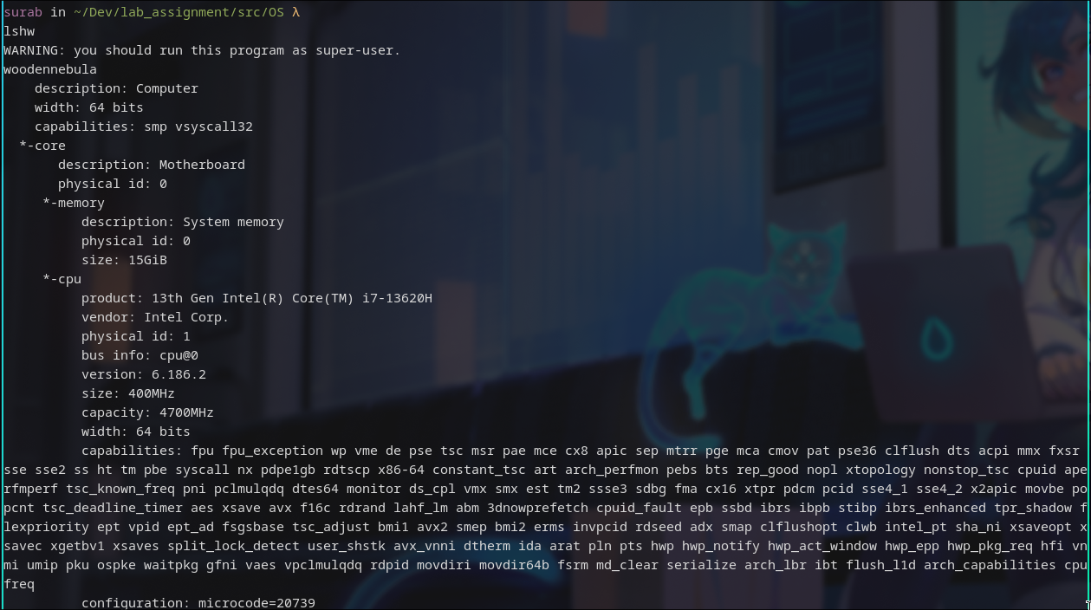

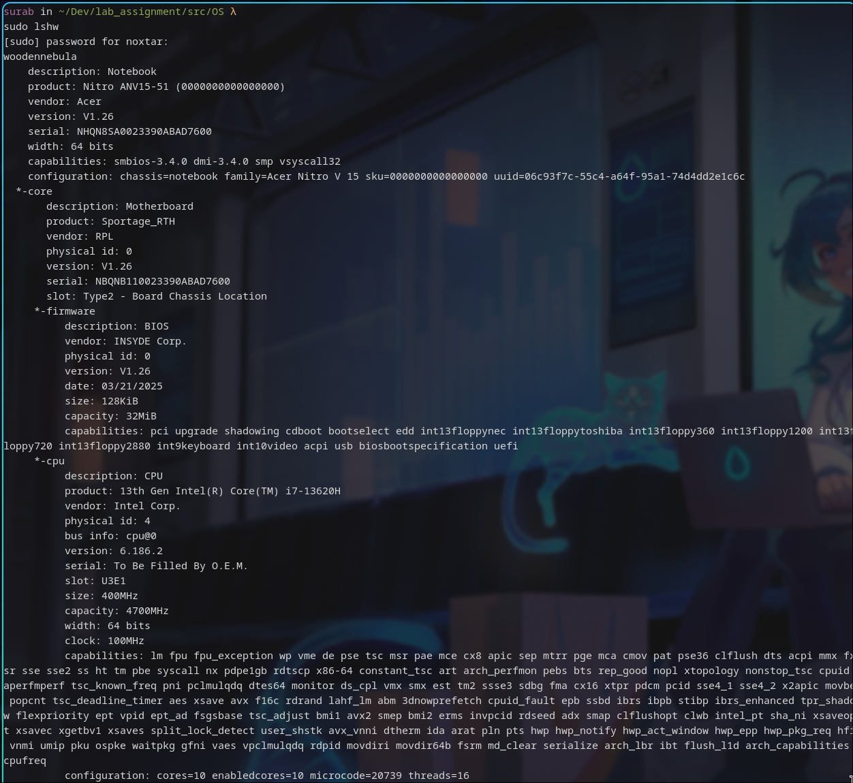

# hwinfo [--short]

Interpretation: hwinfo is used to probe for the hardware present in the system. It can be used to generate a system overview log which can be later used for support.

Output:

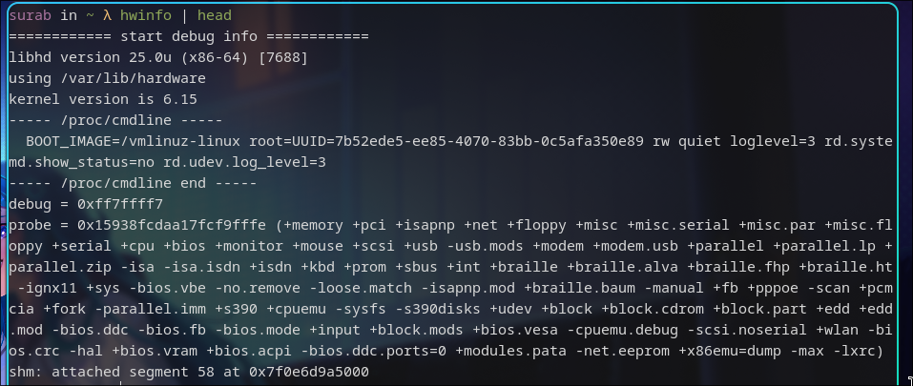

Command: hwinfo --short

Interpretation: Show only a summary.

Output:

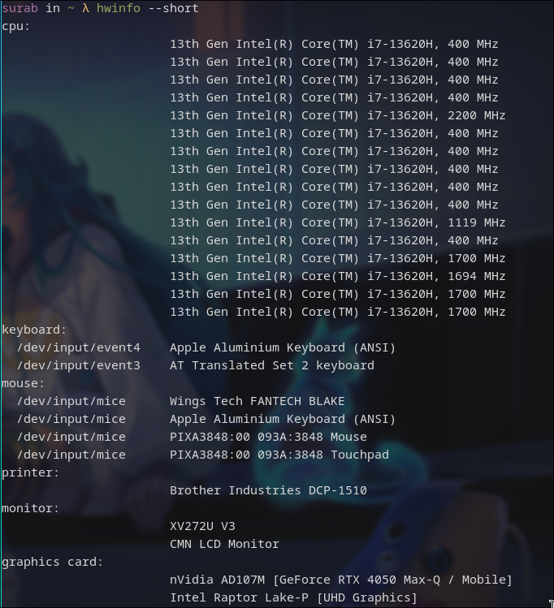

# lspci

Interpretation: lspci is a utility for displaying information about PCI buses in the system and devices connected to them.

Output:

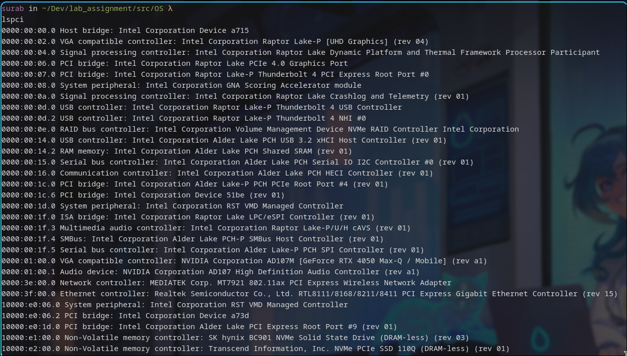

# lsscsi

Interpretation: Uses information in sysfs to list SCSI devices (or hosts) currently attached to the system. Many non-SCSI storage devices (but not all) used the SCSI subsystem in Linux.

Output:

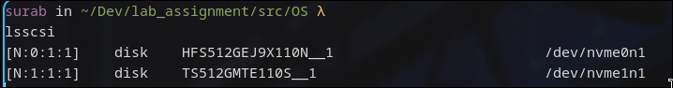

# lsusb

Interpretation: lsusb is a utility for displaying information about USB buses in the system and the devices connected to them. It uses udev's hardware database to associate a full human-readable name to the vendor ID and the product ID.

Output:

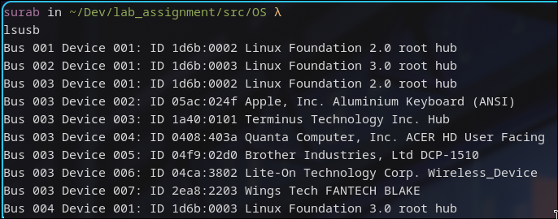

Command: lsusb | tee lsusb.txt  
Interpretation: print each line and write to a file named lsusb.txt



# inxi [-f][-F][-x]

Interpretation: Command line system information tool for console and IRC

Output:

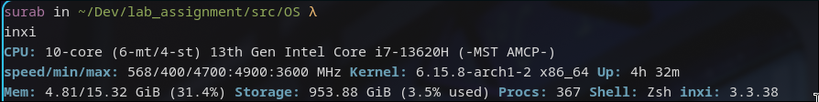

Command: inxi -fx  
Interpretation: Lists all cpu flags used

Output:

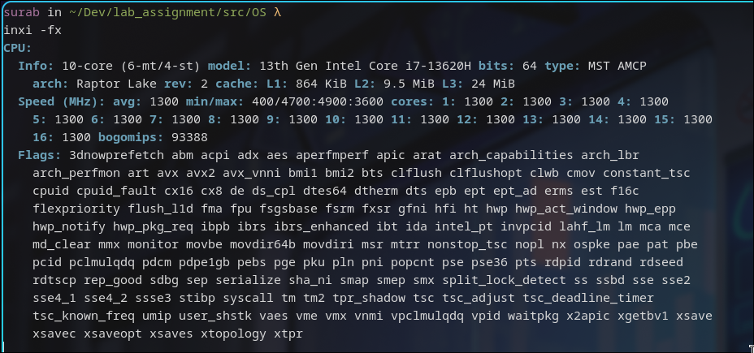

Command: inxi -Fx  
Interpretation: Lists expanded basic CPU data line

Output:

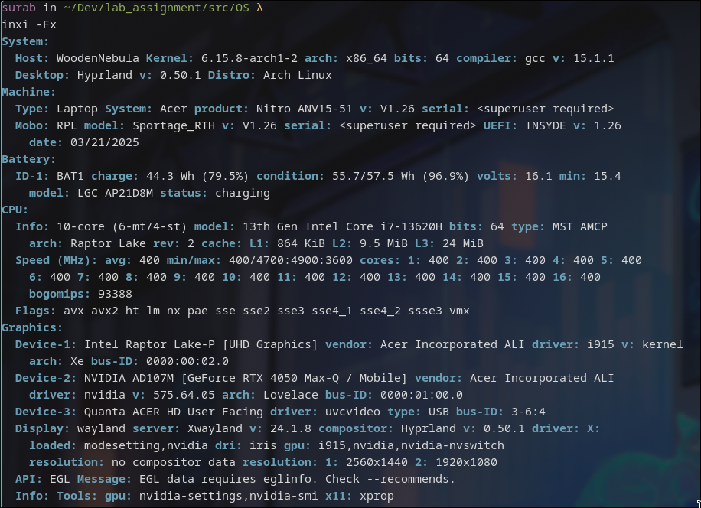

# lsblk

Interpretation: lists information about all available or the specified block devices. The lsblk command reads the sysfs filesystem and udev db to gather information.

Output:

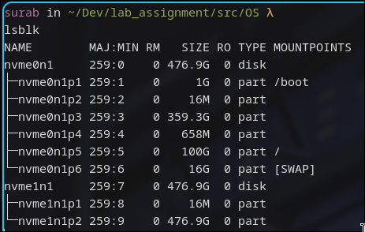

# df

Interpretation: report file system space usage

Output:

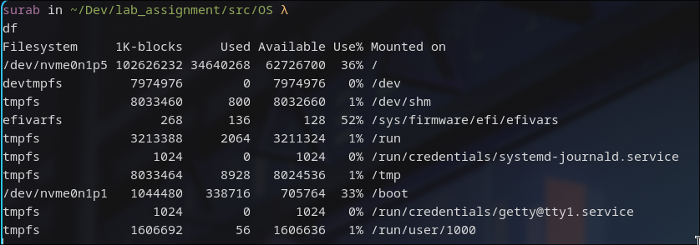

# pydf

Interpretation: ydf is a python script that displays the amount of disk space available on the mounted filesystems, using different colours for different types of filesystems. Output format is completely customizable.

Output:

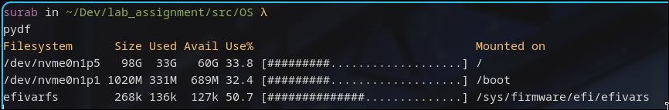

# fdisk [-l]

Interpretation: fdisk is a dialog-driven program for creation and manipulation of partition tables. It understands GPT, MBR, Sun, SGI and BSD partition tables.

Output:

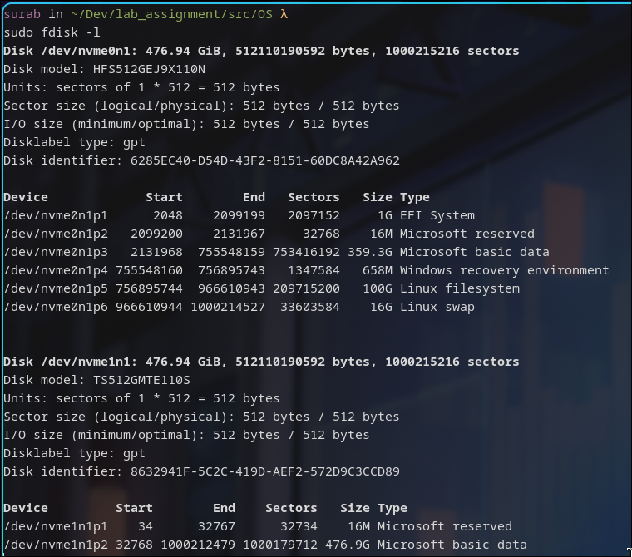

# free

Interpretation: free displays the total amount of free and used physical and swap memory in the system, as well as the buffers and caches used by the kernel. The information is gathered by parsing /proc/meminfo

Output:

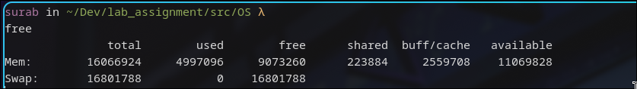

# dmidecode [-t <type>]

Interpretation: dmidecode is a tool for dumping a computer's DMI (SMBIOS) table contents in a human-readable format. This table contains a description of the system's hardware components from which we can retrieve this information without having to probe for the actual hardware.

-t <type> option makes it to only display information for the supplied device type.

Command: sudo dmidecode -t processor

Output:

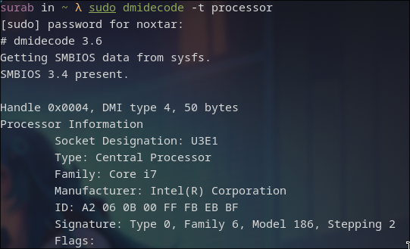

Command: sudo dmidecode -t memory

Output:

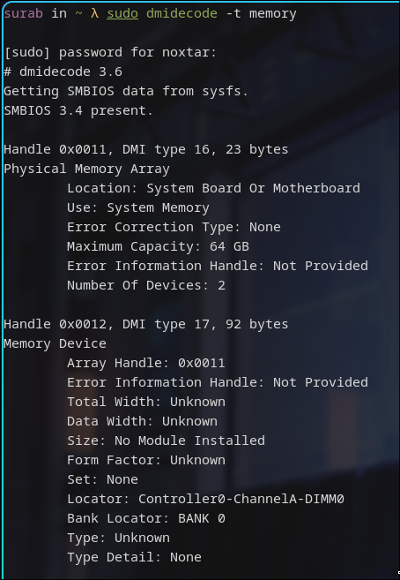

Command: sudo dmidecode -t bios

Output:

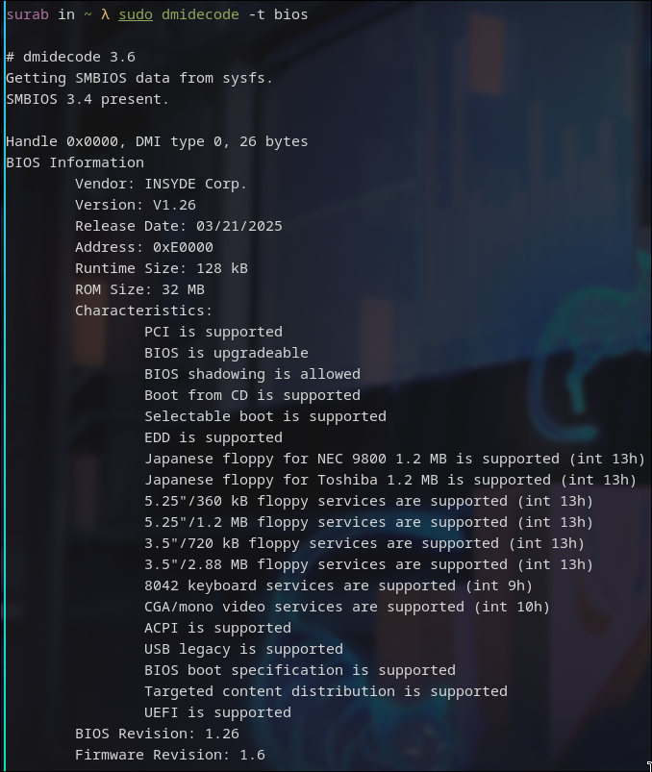

# cat /proc/meminfo

Interpretation: reads file /proc/meminfo and output the various information of memory segments of the computer system.

Output:

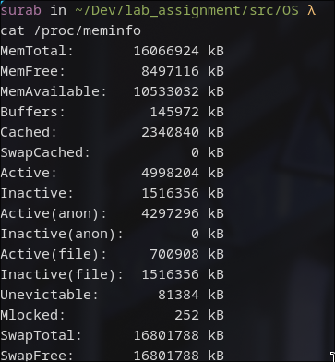

# cat /proc/version

Interpretation: displays the system information in quick summary

Output:



# hdparm [-i </dev/sata_device>]

Interpretation: Displays the identification info which the kernel drivers (IDE, libata) have stored from boot/configuration time for the SATA/IDE device

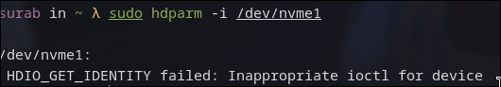Note: My laptop only has NVMe drives, so the command failed

# uname [-n] [-r]

Interpretation: print system information

-n: print the network node hostname

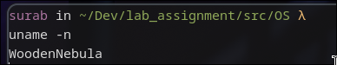

-v: print the kernel version

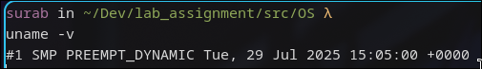

-r: print the kernel release

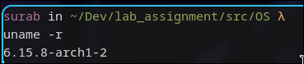

-m: print the machine hardware name

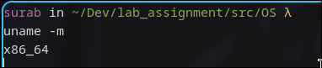

-a: print all the information



# factor

Interpretation: Print the prime factors of each specified integer NUMBER. If none are specified on the command line, read them from standard input.

Output:

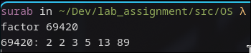

# bc

Command: echo ‘3*9’ | bc

Interpretation: bc is an arbitrary precision calculator language. The expression 3*9 is piped into bc as input to calculate for output.

Output:

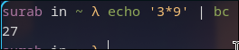

# id

Interpretation: print real and effective user and group IDs

Output:



# shutdown

Interpretation: Halt, power off or reboot the machine, with no params, it shutsdown after 1 minute

Command: shutdown now

Interpretation: Immediately shutdown the machine

Command: shutdown 13:20

Interpretation: Shutdown the machine at 13:20 O’ clock

Command: shutdown 10

Interpretation: Shutdown the machine after 10 mins have elapsed after the command triggers

Command: shutdown -r +10

Interpretation: Restart the machine after 10 mins have elapsed after the command triggers

Command: shutdown -c

Interpretation: Cancel any pending shutdown

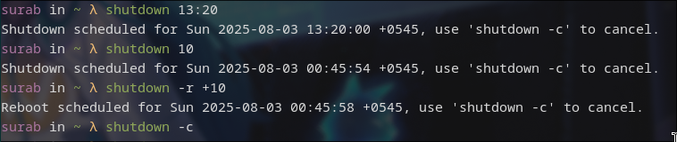

# ping

Command: ping -w3 google.com

Interpretation: send ICMP ECHO_REQUEST to google.com for 3 seconds.

Output:

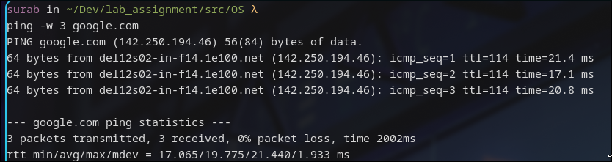

# netstat [-r]

Interpretation: Print network connections, routing tables, interface statistics, masquerade connections, and multicast memberships.

Output:

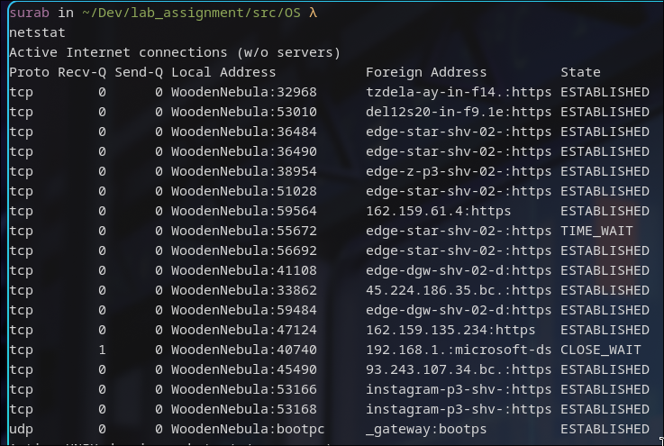

Command: netstat -r   
Interpretation: display kernel routing tables

Output:

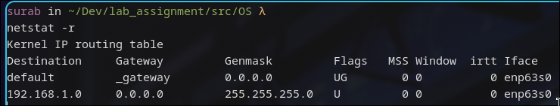

Command: netstat -p   
Interpretation: Show the PID and name of the program to which each socket belongs. A hyphen is shown if the socket belongs to the kernel

Output:

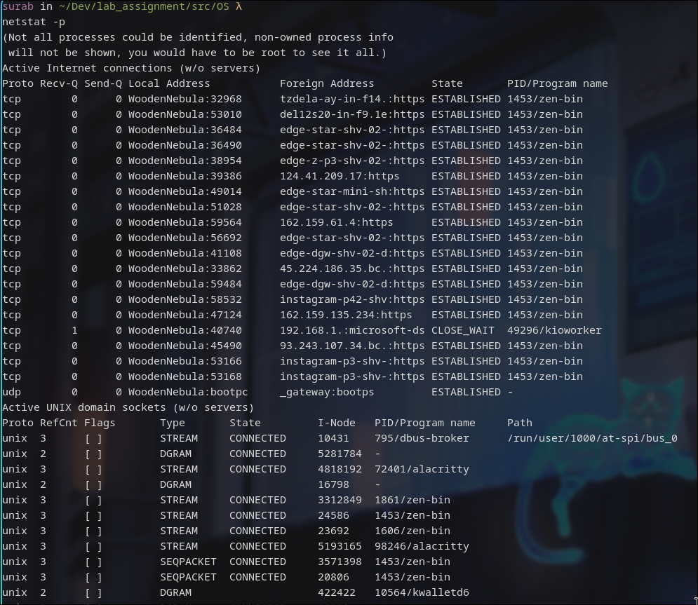

# tcpdump

Interpretation: dump traffic on a network.

Output:

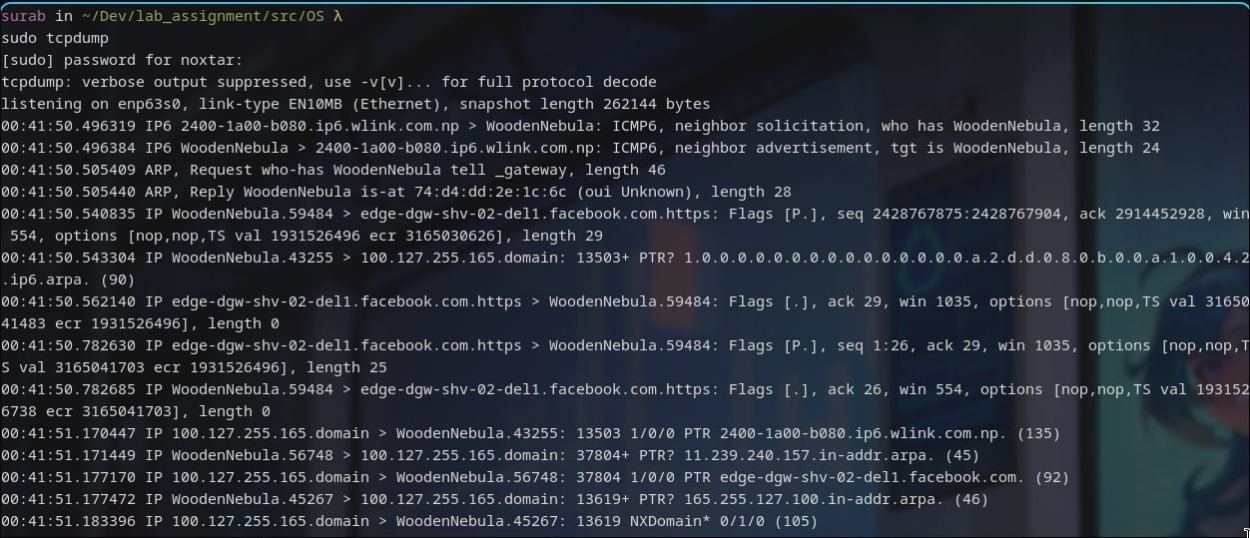

# host google.com

Interpretation: host is a simple utility for performing DNS lookups. It is normally used to convert names to IP addresses and vice versa.

Output:

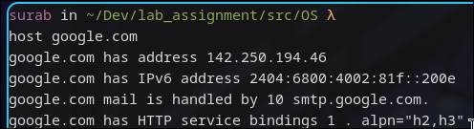

# tracepath achsnepal.edu.np

Interpretation: It traces the network path to destination discovering MTU along this path. It uses UDP port port or some random port. It is similar to traceroute.

Output:

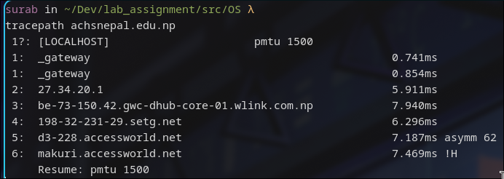

# ifconfig

Interpretation: Ifconfig is used to configure the kernel-resident network interfaces. It is used at boot time to set up interfaces as necessary. After that, it is usually only needed when debugging or when system tuning is needed.

Output:

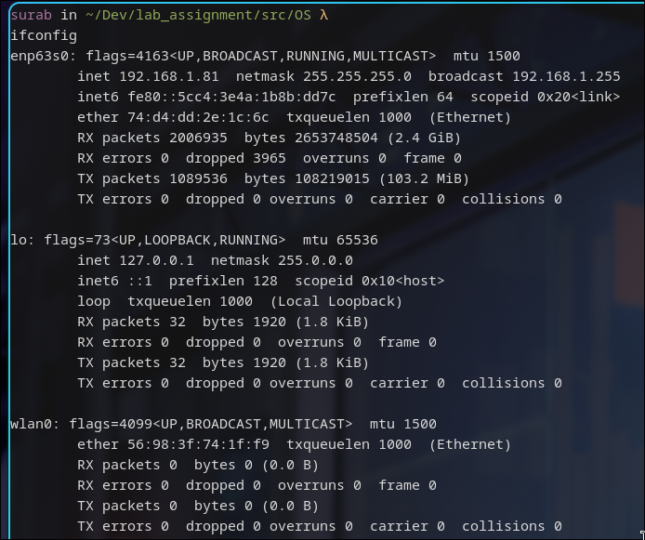

# route

Interpretation: Route shows/manipulates the kernel's IP routing tables.

Output:

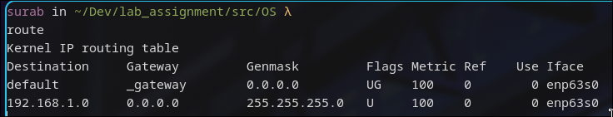

# nslookup

Interpretation: nslookup is a program to query Internet domain name servers. nslookup has two modes: interactive and non-interactive. Interactive mode allows the user to query name servers for information about various hosts and domains or to print a list of hosts in a domain. Non-interactive mode prints just the name and requested information for a host or domain.

Output:

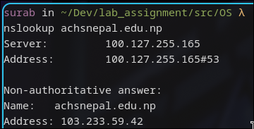

# whois

Interpretation: whois searches for an object in a RFC 3912 database.

Output:

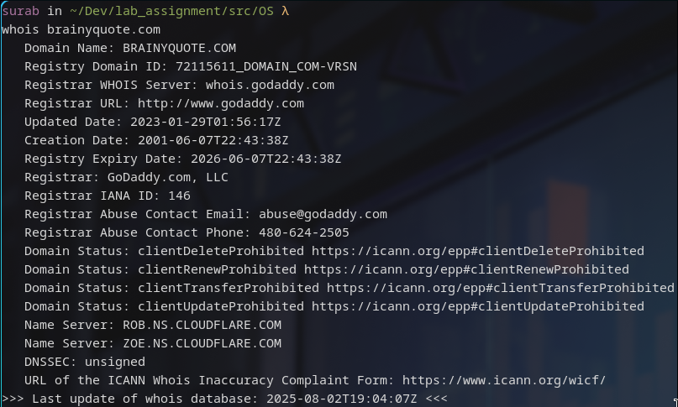

# pacman [-S[yy][u]] [package_name]

pacman is a package manager for arch based distros. It does similar work to apt-get for debian based.

Command: pacman -Syyu

Interpretation: force sync local package cache database and update them

Output:

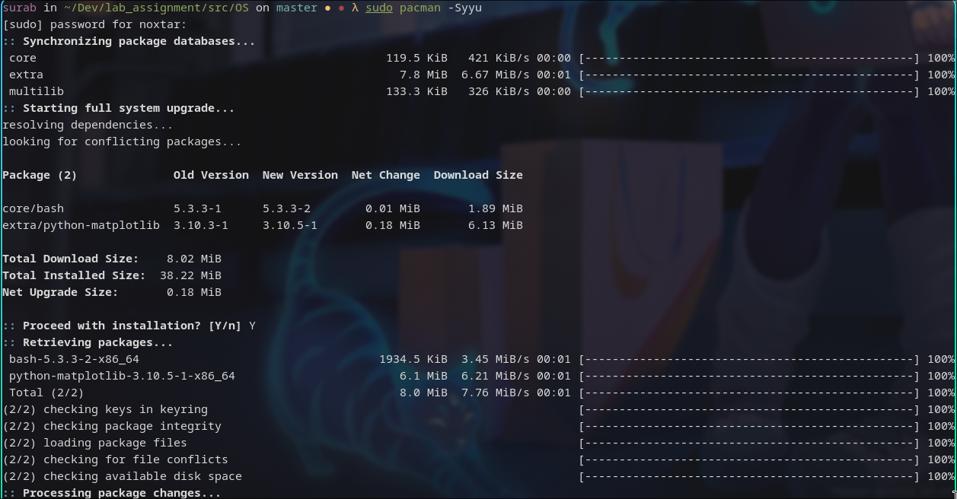Command: pacman -S sl

Interpretation: Searches for a package named sl and installs it if not already installed

Output:

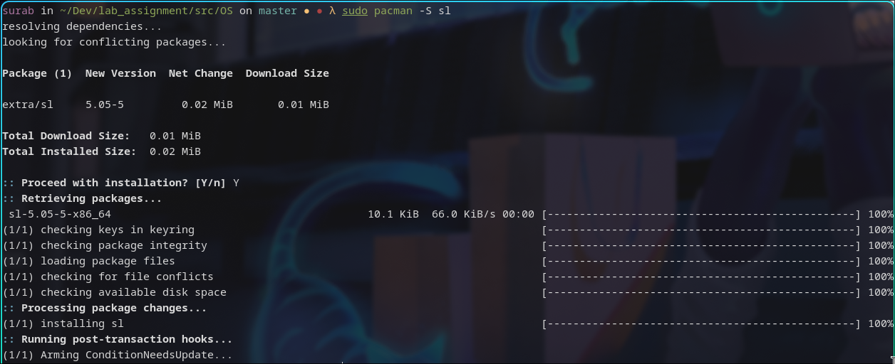

# sl

It is one of many easter egg commands in linux. This one is for typo of ls command.

Output:

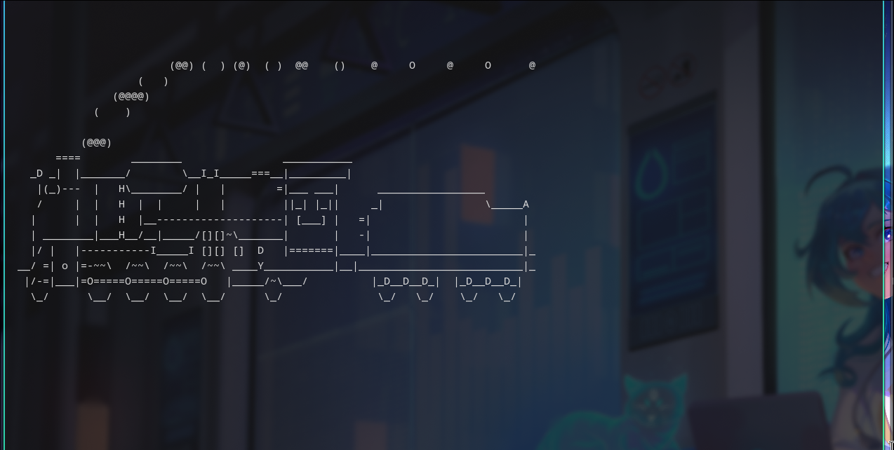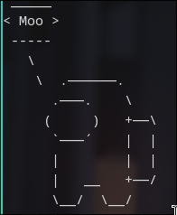

# sudo -s

Interpretation: Change to sudo SHELL for the user

Output:

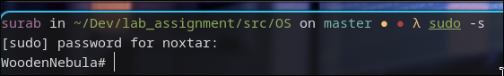

# exit

Interpretation: exits out of current shell environment

Output:

